

ZTS-3000-FSJT-*-* -1

Polycarbonate wind speed sensor

Product Manual

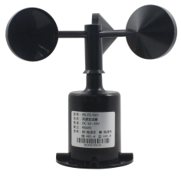

|  |  |
| --- | --- |
| 1 | Overview |

The three-cup wind speed sensor is a wind speed measuring instrument independently developed and produced by our company. The sensor shell is made of polycarbonate composite material, which has good anti-corrosion and anti-corrosion characteristics, it can ensure the long-term use of the sensor without the phenomenon of rust-cut, while cooperating with the internal smooth bearing system to ensure the collection of information. Internal integrated photoelectric conversion mechanism, industrial microcomputer processor, standard current generator, current driver and so on.

The PCB is made of military grade a material, which ensures the stability of measuring parameters and electrical performance, while the electronic component is made of imported industrial grade chips, which make the whole system highly reliable against electromagnetic interference, it can ensure that the main engine can work normally in the range of ー20 ° C ー70 ° C, humidity 5% ー95% Rh (no dewing) .

After the product upgrade, the output signal variety, wired output includes: analog signal (voltage, current) , digital signal RS485; wireless output includes: Lora, GPRS, 4G, wireless output in addition to Lora, other forms can be connected to the cloud platform, the intelligent terminal data monitoring and management.

|  |  |
| --- | --- |
| 2 | Features |

(1) the sensor has compact design and high measuring precision.

(2) fast response and good interchangeability.

(3) to realize low cost, low price and high performance.

(4) the flange installation mode can realize the lower outlet line and the side outlet line, which is simple and convenient.

(5) the data transmission efficiency is high, the performance is reliable, guarantees the normal work.

(6) the power supply has wide application range, good linearity of data information and long signal transmission distance.

(7) with two parameters of wind speed and wind level, the data is reliable.

|  |  |
| --- | --- |
| 3 | Scope of application |

This product is widely used in greenhouse, environmental protection, weather stations, engineering machinery, ships, docks, aquaculture and other environmental wind speed measurement.

|  |  |
| --- | --- |
| 4 | Product information |

The measuring range: 0-30m/s, 0-50m/s, 0-60m/s

Starting wind speed: ≤0.3 m/s

Accuracy: ± (0.2 + 0.03 V) m/s

Output Signal: A: voltage signal (0-2v, 0-5v, 0-10V three choose one)

B: 4-20mA (current loop)

C: RS485(standard Modbus-RTU protocol, device default address: 01)

D: NPN, PNP, NPNR, GPRS, 4G, Lora output

Supply voltage: 10-30V DC

Stabilization Time: < 1 second

Response time: < 1 second

Working Temperature: ー20 ° C ー70 ° C

Working Humidity: ≤100% Rh

Storage Temperature: ー20 ° C ー70 ° C

Storage humidity: ≤100% Rh

Load capacity: voltage output: output resistance ≤250 ω; current output: ≤600 ω

|  |  |
| --- | --- |
| 5 | Use Methods |

Wind speed sensors can be connected to a variety of differential input data acquisition device, data acquisition card, remote data acquisition module and other equipment, wiring description as follows:

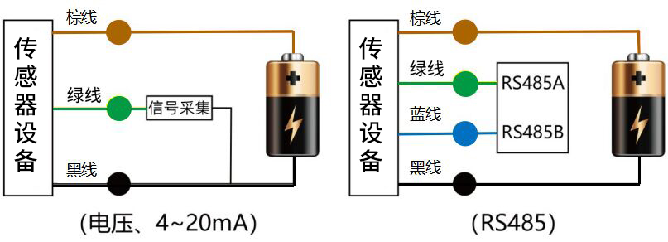

|  |  |
| --- | --- |
| 6 | Shape specifications |

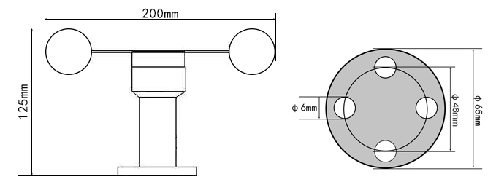

|  |  |
| --- | --- |
| 7 | Data conversion method |

V: the voltage collected by the collector, unit: V;

A: the current collected by the collector, unit: Ma;

|  |  |  |
| --- | --- | --- |
| Output signal | Data conversion method for each range | |
| 0 ~ 30M/s | 0-60m/s |
| 0-2v DC | Wind Speed = 15 * v | Wind Speed = 30 * v |
| 0-5v DC | Wind Speed = 6 * v | Wind Speed = 12 * v |
| 0-10 V DC | Wind Speed = 3 * v | Wind Speed = 6 * v |
| 4-20 Ma | Wind speed = 1.875 * A-7.5 | Wind speed = 3.75 * A-15 |
| Pulse (NPN or PNP) | One pulse per second represents 0.1 m/s | |

RS485 signal (default address 01) :

Standard Modbus-RTU protocol, baud rate: 4800; parity bit: none; data bit: 8; stop bit: 1

**7.1 change of address**

For example: change the address of a sensor with address 1 to 2, host → slave

|  |  |  |  |  |  |  |  |
| --- | --- | --- | --- | --- | --- | --- | --- |
| Original address | Function codes | Start register high | Start register low | The starting address is high | The starting address is low | CRC16 is low | CRC16 high |
| 0X01 | 0X06 | 0X07 | 0XD0 | 0X00 | 0X02 | 0X08 | 0X86 |

If the sensor receives correctly, the data is returned in the same way.

Note: If you forget the original address of the sensor, you can use the broadcast address 0XFF instead, using 0XFF host can only receive a slave, and the return address is still the original address, can be used as an address query method.

**7.2 enquire data**

Query sensor (address 1-RRB- data (wind speed, wind level) , host → slave

|  |  |  |  |  |  |  |  |
| --- | --- | --- | --- | --- | --- | --- | --- |
| Address | Function codes | Start register address is high | The start register address is low | Register length is high | Low register length | CRC16 is low | CRC16 high |
| 0X01 | 0X03 | 0X00 | 0X00 | 0X00 | 0X02 | 0XC4 | 0X0B |

If the sensor receives correctly, return the following data, from machine to host

|  |  |  |  |  |  |  |  |  |
| --- | --- | --- | --- | --- | --- | --- | --- | --- |
| Address | Function codes | Data Length | Register 0 data is high | Register 0 data low | Register 1 data is high | Register 1 data low | CRC16 is low | CRC16 high |
| 0X01 | 0X03 | 0X04 | 0X00 | 0X24 | 0X00 | 0X03 | 0XFA | 0X39 |
|  |  |  | Wind Speed: 3.6 m/s | | Wind level: 3 | |  |  |

|  |  |
| --- | --- |
| 8 | Wind rating scale |

|  |  |  |  |  |  |
| --- | --- | --- | --- | --- | --- |
| Wind power rating | The name of the wind | Wind speed (m/s) | (km/h) | The land phenomenon | State of the sea |
| 0 | No wind | 0-0.2 | Less than 1 | Still, smoke straight up | Calm as a mirror |
| 1 | Soft Wind | 0.3 to 1.5 | One to five | Smoke can indicate the direction of the wind, but the vane can not turn | Microwaves |
| 2 | Soft Wind | 1.6 to 3.3 | 6-11 | The human face feels the wind, the leaves have the slight sound, the wind vane can turn | Little Waves |
| 3 | The Breeze | 3.4 to 5.4 | Twelve to nineteen | Leaves and twigs fluttered, flags unfurled | Little Waves |
| 4 | And the Wind | 5.5 to 7.9 | Twenty to twenty-eight | Can blow up the ground dust and paper, tree branches quiver | Light waves |
| 5 | Fresh Wind | 8.0 to 10.7 | Twenty-nine to thirty-eight | Leafy twigs sway, inland waters have wavelets | Mid-wave |
| 6 | Strong winds | 10.8 to 13.8 | 39 to 49 | Big branches swaying, wires whirring, umbrella difficult to lift | Big Waves |
| 7 | Jil-poong | 13.9 to 17.1 | 50 to 61 | The whole tree shake, feel inconvenient to walk against the wind | Big Waves |
| 8 | Strong Wind | 17.2 to 20.7 | 62 to 74 | When the twigs are broken, one feels great resistance to moving forward | Rough seas |
| 9 | Gale | 20.8 to 24.4 | 75 to 88 | Damage to the building (chimney top and roof tiles moved) | Rough seas |
| 10 | High winds | 24.5 to 28.4 | 89 to 102 | Rare on land, see when the trees can be uprooted will be seriously damaged buildings. | Rough seas |
| 11 | The storm | 28.5 to 32.6 | 103 to 117 | On land, there is little, there must be significant damage | Extraordinary |
| 12 | Hurricane | 32.7 to 36.9 | 118 to 133 | Very few on land, its destructive power | Extraordinary |
| 13 | Hurricane | 37.0 ~ 41.4 | 134 to 149 | Very few on land, its destructive power | Extraordinary |
| 14 | Hurricane | 41.5 to 46.1 | 150 to 166 | Very few on land, its destructive power | Extraordinary |
| 15 | Hurricane | 46.2 ~ 50.9 | 167 to 183 | Very few on land, its destructive power | Extraordinary |
| 16 | Hurricane | 51.0 to 56.0 | 184 to 201 | Very few on land, its destructive power | Extraordinary |
| 17 | Hurricane | 56.1 ~ 61.2 | 202 to 220 | Very few on land, its destructive power | Extraordinary |

|  |  |
| --- | --- |
| 9 | Notes on usage |

(1) please check the packing is intact, and check the sensor model and specifications are consistent with the products you choose.

(2) can not live wiring, wiring check after no error can be electrified.

(3) the user should not change the components and wires that have been soldered when the product leaves the factory.

(4) the sensor belongs to the precision device, the user is in use, please do not disassemble, in order to avoid causing the product damage.

(5) to avoid viscous particles into the sensor, moisture, so as not to affect the measurement performance.

|  |  |
| --- | --- |
| 10 | Product warranty |

The warranty period of this product is one year. From the date of shipment, within 12 months, due to sensor quality problems (non-human damage) caused by failure, the company is responsible for free maintenance or replacement, after the warranty period only cost.